Temperature Gauge Detailed Settings Option Control Function – CGEA 1.3

Functional Description

The Temperature Gauge Detailed Settings feature allows the display of a cluster menu to allow the driver to change the 2 flat response temperature minor gauges to a continuous response. The 2 gauges that are affected are the TFT (Transmission Fluid Temperature) gauge and the ECT (Engine Coolant Temperature) gauge. When “standard” is selected, these gauges follow their traditional transfer function, which has a large flat response band designated as “F” in the curves. When “detailed” is selected, the “F” zone is removed from the transfer function, and the gauge response is now linear from “E” to “G” (Starting edge of normal band to Ending edge of normal band). Also, the actual temperature appears under these 2 minor gauges as well as the EOT (Engine Oil Temperature) gauge. Note the EOT gauge is always linear, so its transfer function is not affected by this menu choice.

It is important to realize that when “standard” is selected, the 3 temperature gauges function normally. Where “normally” is defined by “Digital Gauges Interface - CGEA1.3_v2.3.docx” or equivalent STSS. That STSS defines DE06 configuration parameters for when the numeric temperature display appears below the minor gauge. These parameters are “Eng Temp Dig”, “Trans Temp Dig”, and “Eng Oil Dig”. These 3 parameters have an encoding that allows “Digital Data always off”, “Digital Data Always On”, “Digital Data On at SP1”, “Digital Data On at SP2”. When “Detailed” is selected per this STSS, those 3 configs are over-ridden and treated as “Digital Data Always On”. In other words, the display of the temperature numeric value is an “OR” condition of the DE06 config paramters and the “Detailed” setting.

This feature was created at the request of the MY2023 SuperDuty (F-350) program (P708). This feature may be picked up by other programs in the future. At this time, this is only planned to be offered in truck programs that offer a 5-way steering wheel switch for the cluster. Thus, this STSS only supports this menu in the IPC. It does not support having this menu in the APIM (SYNC).

As part of Enhanced Memory, the cluster shall be storing 5 copies of this feature setting. Thus, a feature ID of 0x0972 has been assigned.

Temperature Gauge Detailed Settings Control Function is displayed only in the Message Center while it is in the appropriate SETUP display. See Message Center X Display_Y Button Interface Section, where X and Y are appropriate values in this document for details on when this display is active.

Interfaces

Interface Context Diagram (I/O Block Diagram)

Temperature Gauge Detailed Settings Option Context Diagram

Inputs

IR-REQ-405705/A-INTERNAL:
- Operational_Mode
- M/C Switch Event
- M/C_Display_Status
- Temp_Gauge_Detail_Settings_Menu_Cfg
- Current_PERS (refer to “Personalization - Cluster Owned Features – Units/Language - CGEA1.3” STSS)

Outputs

IR-REQ-405716/A-Internal (Non-MUX)

- Temp_Gauge_Detail_Menu_Status_Flag
- TEMP_GAUGE_DETAIL_SETUP_MC

Function/Performance

F-REQ-405722/A-Operational Modes

Mode | Differentiating Vehicle Conditions
Sleep Mode | Temperature Gauge Detailed Settings Control Function Disabled
Limited Mode | Temperature Gauge Detailed Settings Control Function Disabled
Normal Mode | Temperature Gauge Detailed Settings Control Function Enabled/Disabled
Crank Mode | Temperature Gauge Detailed Settings Control Function Enabled/Disabled

Voltage Levels

Refer to the Cluster Features table located in the Operational Modes and Voltage Range Strategies Section in this SPSS.

Human-Machine Interface

Visual

Indicator Graphics / Display Format
Refer to “<Program> Cluster Menu Structure and Menu Nav.xls”

Menu Level 1 | Menu Level 2 | Menu Level 3 | Menu Level 4
Settings > | Configure Gauges > | Temperature Gauge Option > | Standard   (default)
Settings > | Configure Gauges > | Temperature Gauge Option > | Detailed 
Note: The “Temperature Gauge Option” menu selection is not shown when Temp_Gauge_Detail_Settings_Menu_Cfg = 0x0 (Disabled)

HMI-REQ-405706/A-Temperature Minor Gauge Numeric Display when Temp_Gauge_Detail_Menu_Status_Flag = 0x1(Detailed)
- When graphical gauge is shown, shall also display the numerical temperature in the selected unit when Temp_Gauge_Detail_Menu_Status_Flag = 0x1(Detailed). This applies to:
  - Engine Coolant Temperature (ECT) Gauge
  - Transmission Fluid Temperature (TFT) Gauge
  - Engine Oil Temperature (EOT) Gauge

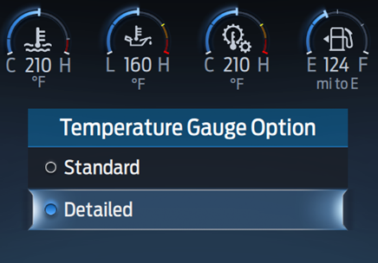

HMI-REQ-405707/A-Temperature Minor Gauge Numeric Display when Temp_Gauge_Detail_Menu_Status_Flag = 0x0(Standard)
- When graphical gauge is shown, the numerical temperature display is not affected when Temp_Gauge_Detail_Menu_Status_Flag = 0x0(Standard). (i.e. follow “Digital Gauges Interface - CGEA1.3” or equivalent STSS)
This applies to:
  - Engine Coolant Temperature (ECT) Gauge
  - Transmission Fluid Temperature (TFT) Gauge
  - Engine Oil Temperature (EOT) Gauge

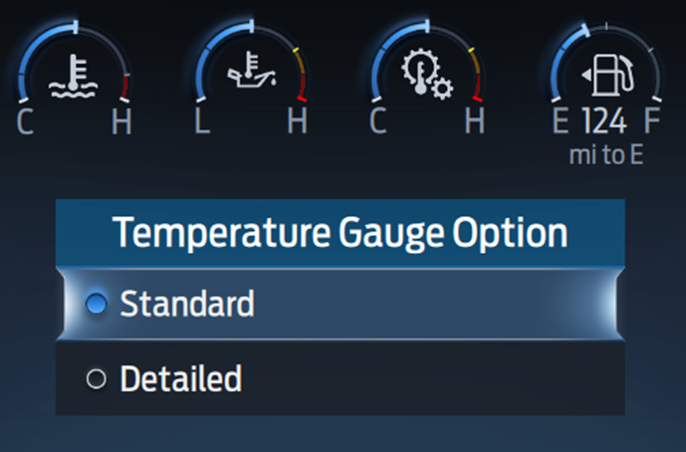

Note: In this example, the 3 minor temperature gauges are in the flat response zone and therefore are not showing the numerical temperature value.

HMI-REQ-405708/A-Temperature Gauges IOD Display when Temp_Gauge_Detail_Menu_Status_Flag = 0x1(Detailed)
- When Temp_Gauge_Detail_Menu_Status_Flag = 0x1(Detailed), an additional “Temp Gauges IOD” screen showing ECT and TFT becomes available per the Menu Structure. This IOD is no longer available when Temp_Gauge_Detail_Menu_Status_Flag = 0x0(Standard).

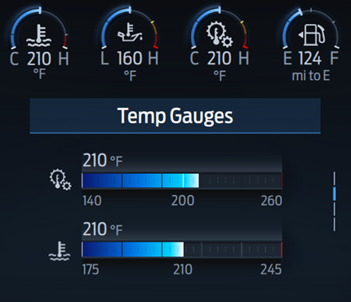

Indicator Color Coordinates

Reference section COLOR & ILLUMINATION REQUIREMENTS (GRAPHICS)

Indicator Characteristics

Refer to Message Center X Display_Y Button Interface Section, where X and Y are appropriate values in this document.

Audio

None.

Switch Control Logic

Consumer access to the Temperature Gauge Detailed Menu Control Function shall be as specified in the message center basic functionality display as specified in Message Center X Display_Y Button Interface Section, where X and Y are appropriate values in this document.

PFM-REQ-405721/A-System Accuracy

Within a 100msec of receiving a message that results in a change of state the cluster will update the display to the proper status.

Operation: Performance and Functional

Subsystem Algorithm Flowchart / State Diagram

F-REQ-405709/A-Temperature Gauge Detailed Menu Diagnostic Configuration Flowchart

F-REQ-405710/A-Temperature Gauge Detailed Menu Flowcharts – Profile Recall

F-REQ-405711/A-Temperature Gauge Detailed Menu Control Function Flowchart

NOTE: In the Temperature Gauge Detailed Menu Control Function Flowchart, the definition of "MC Switch Event" is defined in Message Center X Display_Y Button Interface Section, where X and Y are appropriate values in this document.

Operation Description (supports algorithm flowchart /state diagram)

F-REQ-405712/A-Temperature Gauge Detailed Menu Display and Next Temp_Gauge_Detail_Menu_Status_Flag State based upon TEMP_GAUGE_DET

TEMP_GAUGE_DETAIL_SETUP_MC | Display Setup Menu | M/C Switch Event to Change Setting? | Next TEMP_GAUGE_DETAIL_SETUP_MC  and Next Temp_Gauge_Detail_Menu_Status_Flag  State
0x0 (Standard) | Standard   Detailed  | True (Select Detailed) | 0x1 (Detailed)
0x1 (Detailed) | Standard   Detailed  | True (Select Standard) | 0x0 (Standard)
Note: The “Temperature Gauge Option” menu selection is not shown when Temp_Gauge_Detail_Settings_Menu_Cfg = 0x0 (Disabled)

F-REQ-405713/A-Minor Gauge Transfer Function for Engine Coolant Temperature (ECT) when Temp_Gauge_Detail_Menu_Status_Flag = 0x1(De
- When Temp_Gauge_Detail_Menu_Status_Flag = 0x1(Detailed) the “F” zone is removed from the transfer function, and the gauge response is now linear from “E” to “G” (Starting edge of normal band to Ending edge of normal band). The flat zone is returned when Temp_Gauge_Detail_Menu_Status_Flag = 0x0(Standard).

F-REQ-405714/A-Minor Gauge Transfer Function for Transmission Fluid Temperature (TFT) when Temp_Gauge_Detail_Menu_Status_Flag = 0x
- When Temp_Gauge_Detail_Menu_Status_Flag = 0x1(Detailed) the “F” zone is removed from the transfer function, and the gauge response is now linear from “E” to “G” (Starting edge of normal band to Ending edge of normal band). The flat zone is returned when Temp_Gauge_Detail_Menu_Status_Flag = 0x0(Standard).

F-REQ-405715/A-Personalization Feature Number Definition:

Feature Name | Feature Num | Cfg Num | Cfg Value
Temperature Gauge Option - Cluster Menu | 0x0972 | 0x0 | Standard
Temperature Gauge Option - Cluster Menu | 0x0972 | 0x1 | Detailed

FS-REQ-405724/A-Function Safety Classification (EMC)
Class B

NVM-REQ-405718/A-Memory Storage

Parameter Name | Description | Value at  Battery Connect | Value at  Module Wake-up
Temp_Gauge_Detail_Settings_Menu_Cfg | Configure cluster to display Temperature Gauge Option – Standard/Detailed menu (set at VOPS end of line) | Do Not Init | Do Not Init
TEMP_GAUGE_DETAIL_SETUP_MC | Output displayed in the M/C for Configure Gauges -> Temperature Gauge Option – Standard/Detailed menu setting.  0x0 = Standard  0x1 = Detailed | Use Stored Value of Feature 0x972[5] | Do Not Init
Feature 0x972[5] | Memory storage in EEPROM for Temperature Gauge Option –Standard/Detailed for personalities (PERS_1, PERS_2, PERS_3, PERS_4, Vehicle). This is part of 2-D array TBL_IPC_OWNED_FEATURE_CONFIG[ ].  Default value is Standard (0x0) for all 5 personalities. | Use Stored values | Do Not Init
M/C_Display_Status | State Indicator to identify which text is currently being displayed on Message Center display. See * | See * | See*
M/C Switch Event | Event that is indicated as per the switch interface for the Message Center. See * | See * below | See * below
Operational_Mode | 4 state indicator for cluster operational mode | Limited | Limited, Normal or Crank
Temp_Gauge_Detail_Menu_Status_Flag | Status Flag indicating the state of the Temperature Gauge Option – Standard/Detailed setting | Standard (0x0) | Do Not Init
* Refer to Message Center X Display_Y Button Interface Section, where X and Y are appropriate values in this document.

Reconfigurable Telltale

Not Applicable

Prove Out

Not applicable

Message Center Msg

Refer to Message Center Function description reference "Text Message List - BEF Displays 2x14.xls" file.

Error Handling

Missing Message Strategy

N/A.

Diagnostics

Self Test

None

Engineering Test Mode

Reference section “Dealer / Engineering Test Mode (ETM)”

Part II Performance

DTC-REQ-405719/A-Supported Diagnostic Trouble Codes (DTCs)

DTC | Description
None

DID-REQ-405720/A-DID DExx

Block  Num | Block Description | Byte(s) | Bits | State: Description | "0" | "1" | Default | Comments/Information
PACKETED BLOCKS
$0A | Option Content (B&A) | * | * | Temperature Gauge Detailed Settings Menu | Disabled | Enabled | Disabled | This parameter allows the menu choice for Configure Gauges -> Temperature Gauge Option -> Standard/Detailed to be displayed in the cluster.  When “Detailed” is selected, both TFT and ECT gauges change from flat response to linear response.  This menu choice is being introduced on P708 (SuperDuty) in MY23.  This menu is assumed always in cluster at this time (and not in SYNC).  Would only expect this to be enabled on a few Truck programs.
 | *Byte and bit location to be identified in Part II Specification for this cluster

Reference Specification

Revision History
SPSS Module Revision History

Revision Level | Name | Change Description | Date
1.0 | S. Watkins | Initial release. This is the final half of DI CC #596. Andrew Brown on behalf of Aaron Bresky brought in a request for SuperDuty (P708) for “live” gauges for ECT and TFT (instead of the traditional flat response). This had been approved for Ford Performance, but not mainstream vehicles. The compromise was to add a menu pick for “live” (detailed) temperature gauges, with a default of flat response (standard). This was also reviewed with PCM and TCM calibration teams including Trzeciak, Robert (R.T.) <rtrzecia@ford.com>; Bailey, Owen (O.R.) <obailey@ford.com>; Nickerson, Kurt (K.H.) <knickers@ford.com>; Badger, Dan (D.J.) <dbadger@ford.com>; Rollinger, John (J.E.) jrolling@ford.com, and Jeff Gertley for Driver Information. | 1/4/2021

